API FLOW:

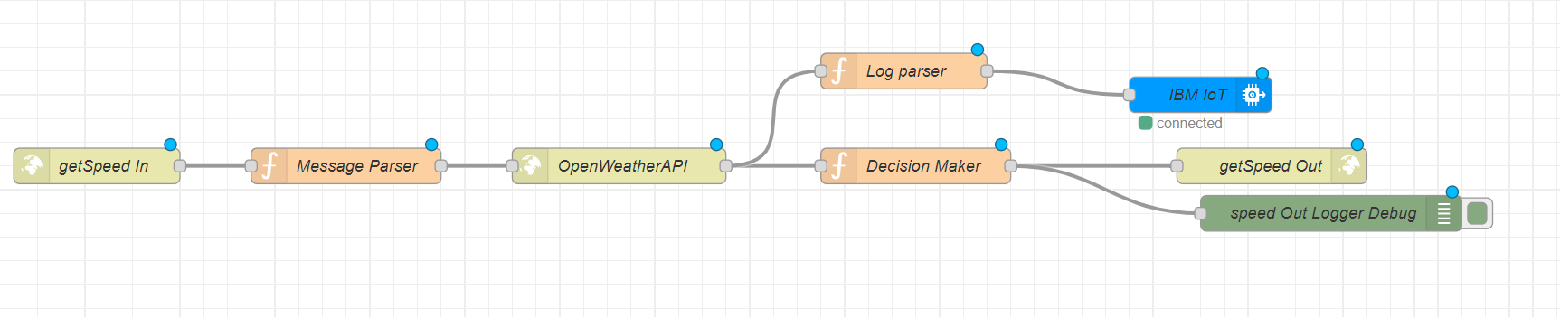

AUTHORITY GIVING TAKE LEFT DIRECTION:

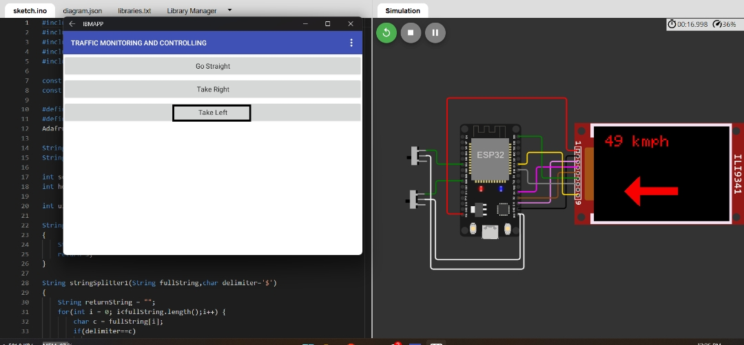

AUTHORITY GIVING TAKE RIGHT DIRECTION:

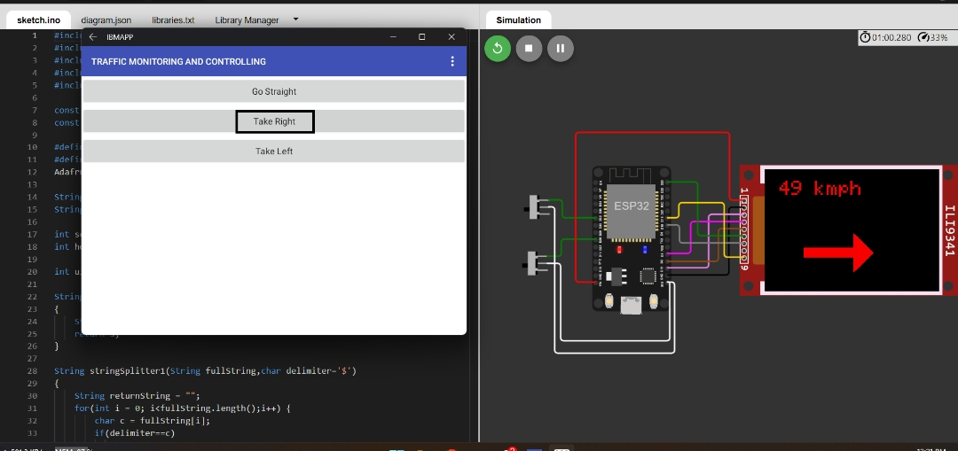

AUTHORITY GIVING TAKE STRAIGHT DIRECTION:

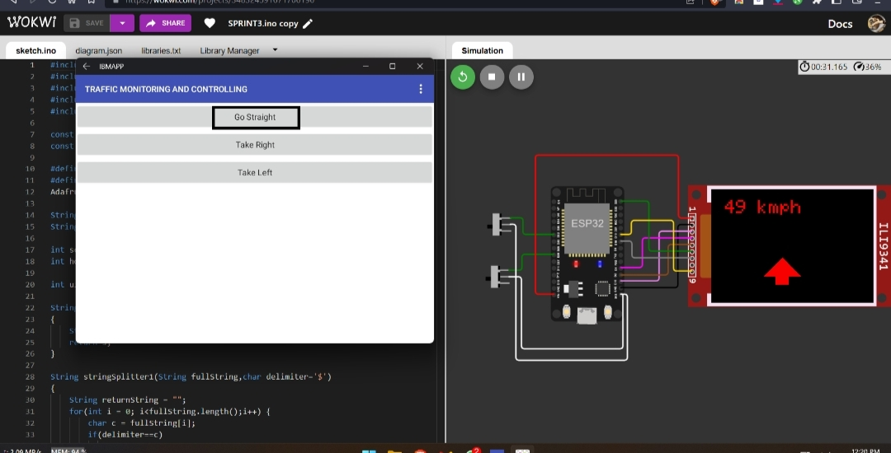

DASHBOARD:

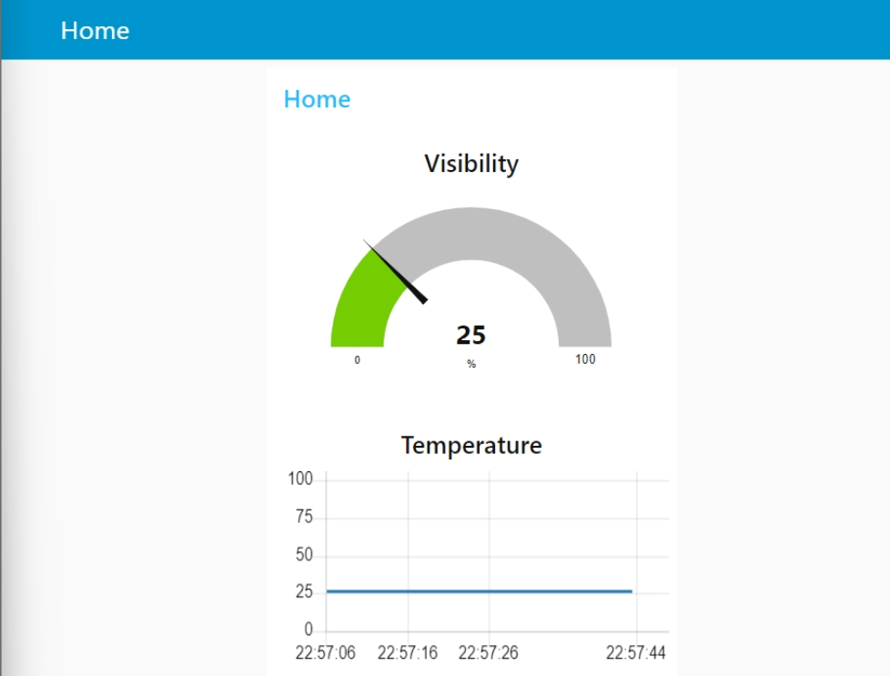

DIRECTION FLOW:

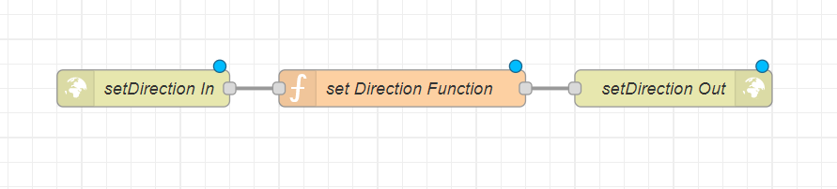

ESP32 CIRCUIT DIAGRAM:

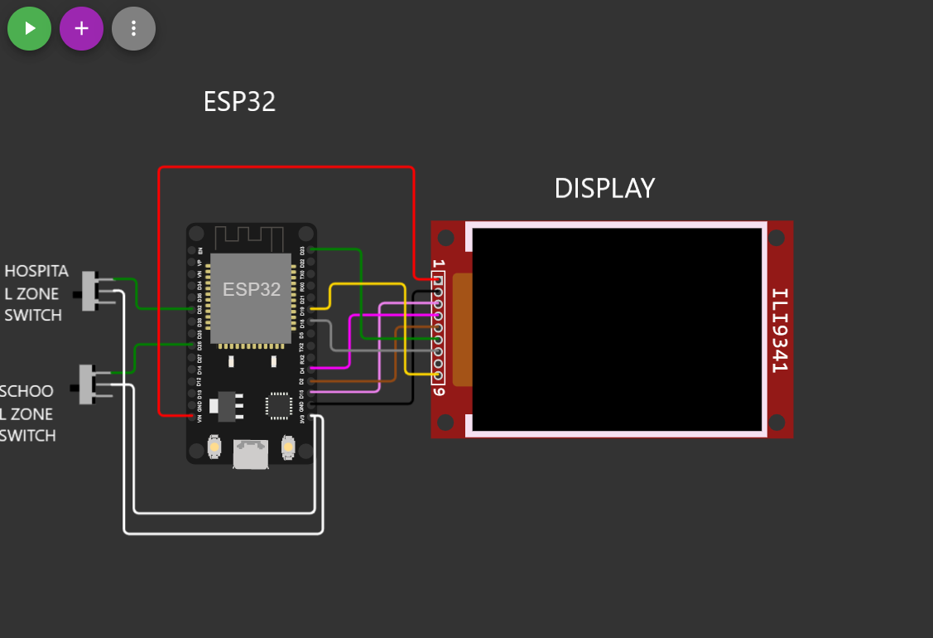

IOT UI FLOW:

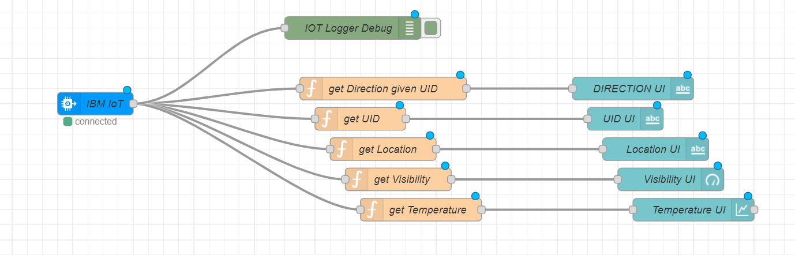

MIT APP BLOCK CODE FOR MANAGING TRAFFIC:

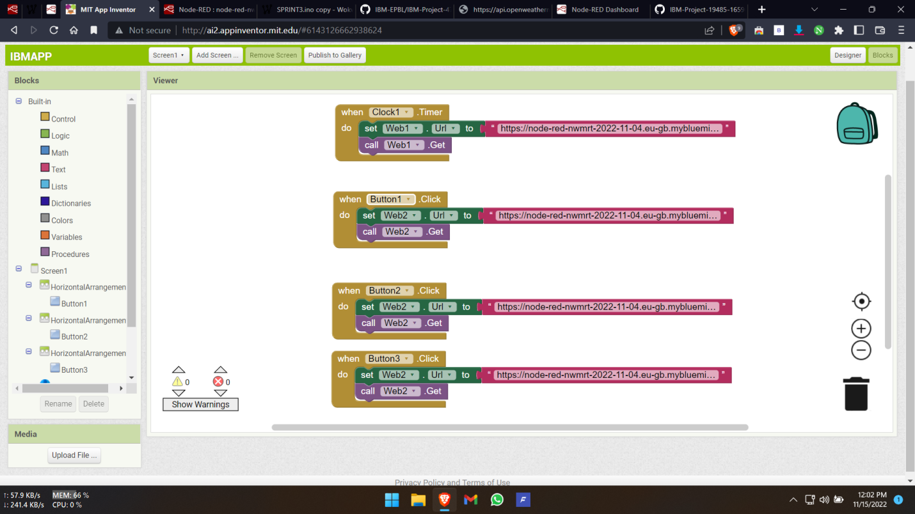

MIT APP UI FOR AUTHORITIES:

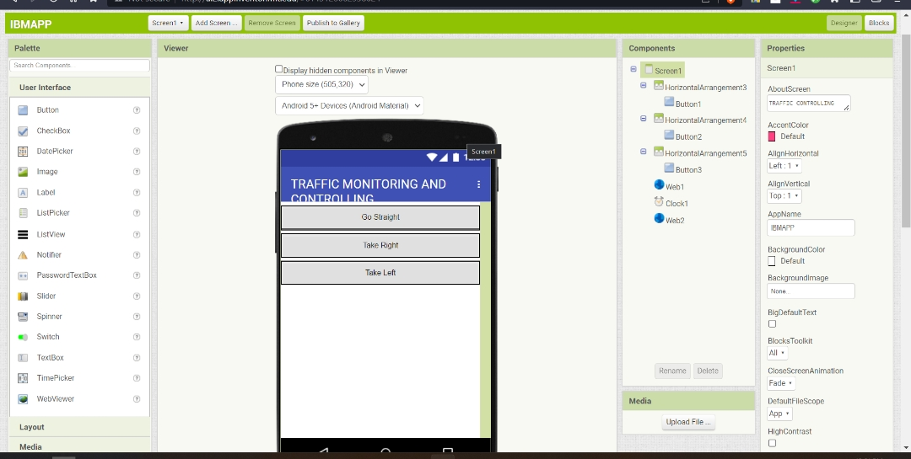

OVERALL NODE RED FLOW:

